Matrix Size:5000×5000

Six loop orders:

i-j-k

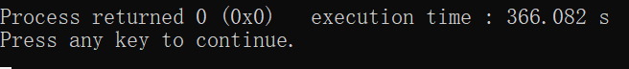

j-i-k



j-k-i



k-j-i



k-i-j



i-k-j

